Child Routes

Suppose we want that when we select a particular DepartmentDetails , We want to further display that department Overview & Contact

Create 2 components

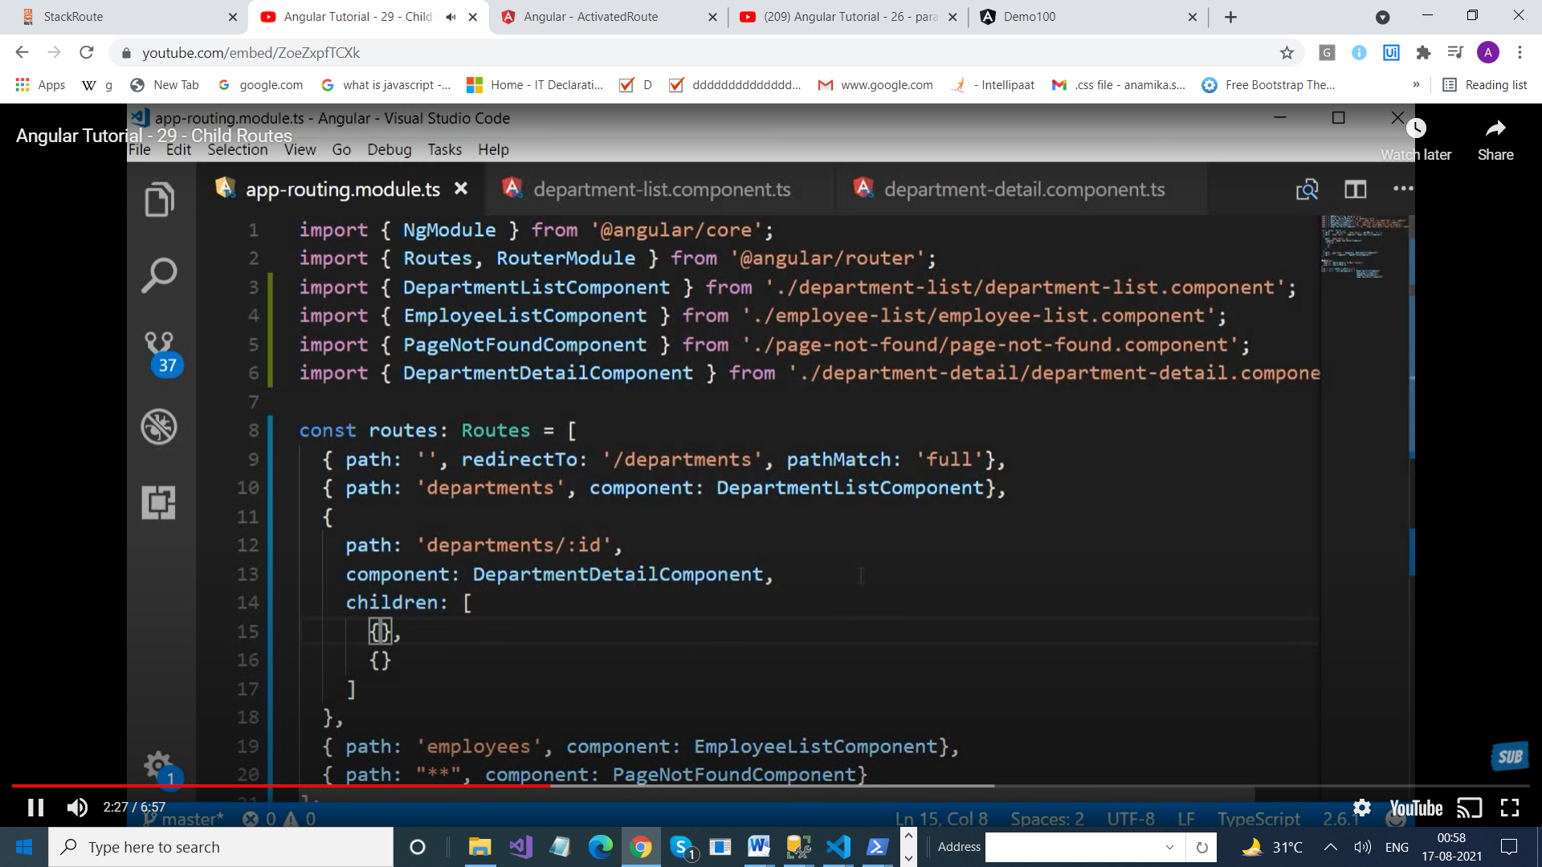

import { NgModule } from '@angular/core';

import { Routes, RouterModule } from '@angular/router';

import { EmployeeListComponent } from './employee-list/employee-list.component';

import { DepartmentListComponent } from './department-list/department-list.component';

import { NotFoundComponent } from './not-found/not-found.component';

import { combineLatest } from 'rxjs';

import { DepartmentDetailsComponent } from './department-details/department-details.component';

import { DepartmentOverviewComponent } from './department-overview/department-overview.component';

import { DepartmentContactComponent } from './department-contact/department-contact.component';

const routes: Routes = [

  {path:'', redirectTo: '/departments', pathMatch:'full'},

  {path : 'departments', component: DepartmentListComponent},

  {path: 'departments/:id' , component:DepartmentDetailsComponent,

 children :[

   {path:'overview' ,component : DepartmentOverviewComponent},

   {path:'contact', component: DepartmentContactComponent}

 ]

  },

  {path: 'employees', component: EmployeeListComponent},

  {path:'\*\*' , component:NotFoundComponent}

];

@NgModule({

  imports: [RouterModule.forRoot(routes)],

  exports: [RouterModule]

})

export class AppRoutingModule { }

export const routingComponents =[DepartmentListComponent,  EmployeeListComponent,  NotFoundComponent,

DepartmentListComponent];

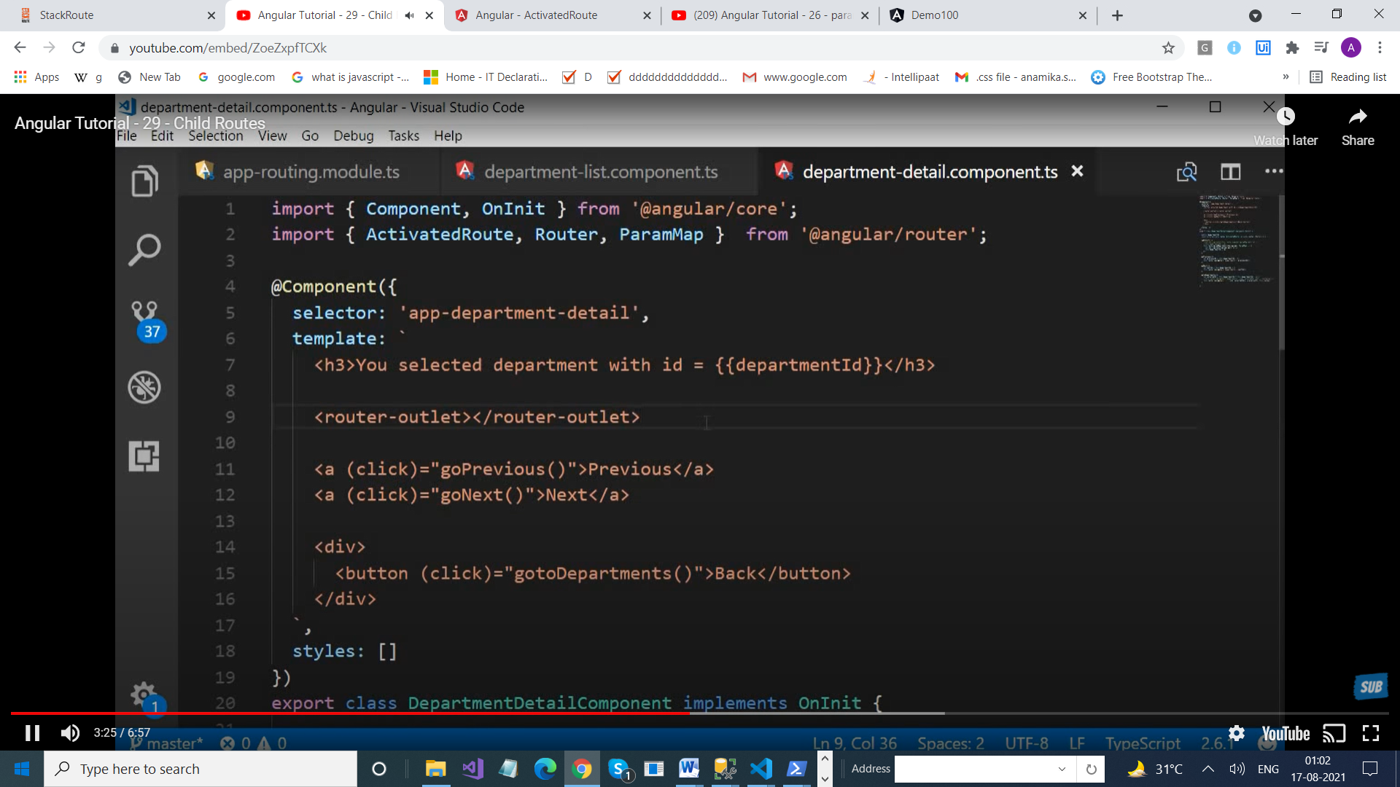

import { ThrowStmt } from '@angular/compiler';

import { Component, OnInit } from '@angular/core';

import { ActivatedRoute, Router , ParamMap } from '@angular/router';

@Component({

  selector: 'app-department-details',

  template: `

    <h3>

     You have selected {{departmentId}} </h3>

     <p>

     <button (click)="overview()"> Show Overview </button>

     <button (click)="contact()"> Show Contact </button>

     </p>

     <router-outlet> </router-outlet>

        <a (click)="goNext()"> Next </a>

        <a (click)="goPrevious()"> Previous </a>

  `,

  styles: [

  ]

})

export class DepartmentDetailsComponent implements OnInit {

  constructor(private activatedroute : ActivatedRoute , private router : Router) { }

  public departmentId : number;

  ngOnInit(): void {

  //let id = this.activatedroute.snapshot.paramMap.get("id");

  this.activatedroute.paramMap.subscribe((params) => {

    console.log(params);

    let id=parseInt(params.get("id"));

    this.departmentId = id;

  });

  }

  goPrevious()

  {

  let previousId=  this.departmentId -1;

  this.router.navigate(["/departments", previousId]);

  }

  goNext()

  {

  let nextId=   this.departmentId + 1;

  this.router.navigate(["/departments", nextId]);

  }

  overview()

  {

this.router.navigate(['overview'], {relativeTo:this.activatedroute});

  }

  contact()

  {

    this.router.navigate(['contact'], {relativeTo:this.activatedroute});

  }

}